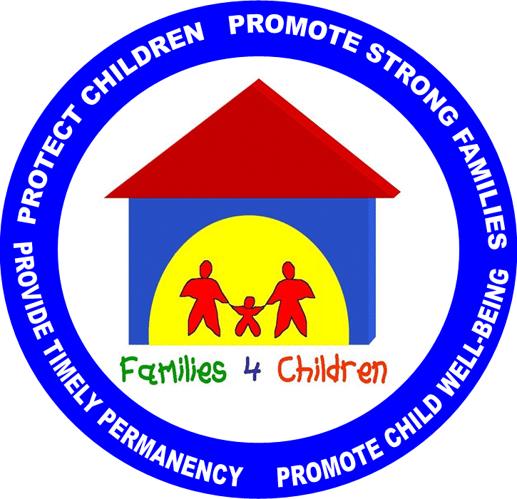
Pennsylvania Drug & Alcohol In-Depth Analysis
Work Plan
Key Issues | Key Action Steps | Target Date | Lead Parties
Mission, Underlying Values, Collaborative Relationships and Priorities
Daily Practice: Screening and Assessment
Daily Practice: Engagement and Retention
Daily Practice: Services to Children
Working with Communities and Supporting Families
Communication, Data Sharing and Information Systems
Budgeting and Sustainability
Training and Staff Development
Working with Related Agencies
Joint Accountability and Shared Outcomes

