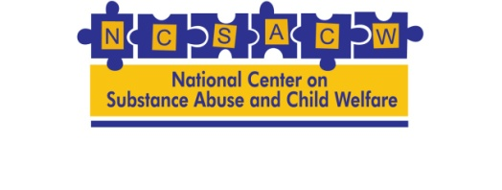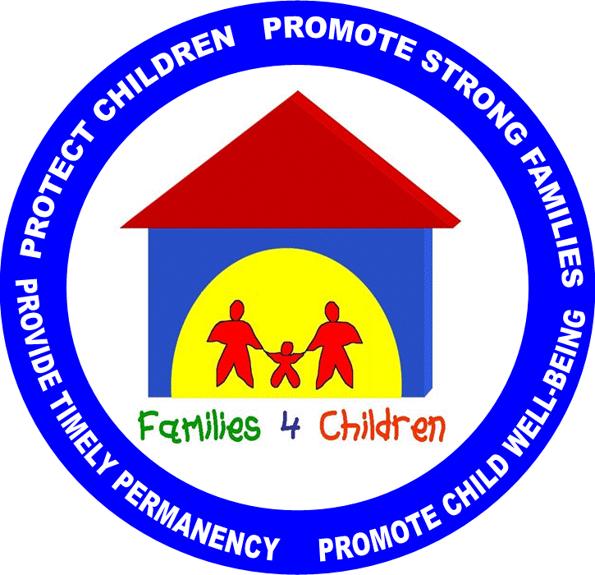
Pennsylvania Drug & Alcohol In-Depth Analysis
System Walk-Through Questions

A System Walk-Through is a proven process designed to assess the effectiveness of the system in achieving its desired outcomes, such as reunifying families, successful treatment completion and ensuring children are living in safe and stable environments. The primary purpose of a Walk-Through is to provide key stakeholders with:

- A good understanding of the system as it currently exist;
- To identify any problem areas (e.g. inconsistency of referrals, delays in accessing treatment, lack of services/involvement from critical stakeholders, problems with engagement and retention, lack of communication across systems); and
- To generate ideas for improving organizational processes.

Each agency should walk through their own system and answer the following questions as the system currently functions. In the process of doing so you can also think about information that is missing, processes that may be clear or make sense, and recommendations for improving how the system works. Please be specific enough to be able to walk your partners through this process. Insert additional rows as needed to capture all critical steps. If there are areas that are not applicable or for which you don’t have information to leave blank.

Target Population: Be specific about the population being served (e.g. all referrals to Hotline, removals, mothers with children, adults, child, etc.). Please include other information/decisions that were made regarding this population if helpful to understand how they got to this point.
Actions | Tools | Decisions | Data | Questions, Concerns, System  Improvement Recommendations
Specify steps for each point in the process. Who does what? When? Why? Where? How (may be tools used in the next column)?  Start from the point of referral or entry into this part of your system through termination, case closure… Be specific about your starting and ending point and what each step is called. Make certain to include any case planning, joint case planning, transition planning, and aftercare. | Safety-Risk Assessment, substance use screen, multi-dimensional assessment,…? Please include the name of the tool. | What decisions are made at this point? By whom? Using what information? Who else is notified? How do you measure progress? | - What data/information is collected? By whom?  - Where is this information stored (data system, separate file,…)?  - By whom?  - How is it accessed?  - Is it accessible to others who need the information? Who? How? Why?
Referral to or Entry Into this part of your System (How is it that they got to this point?)
Case Closure/Discharge
Aftercare/ Follow-up Support

