

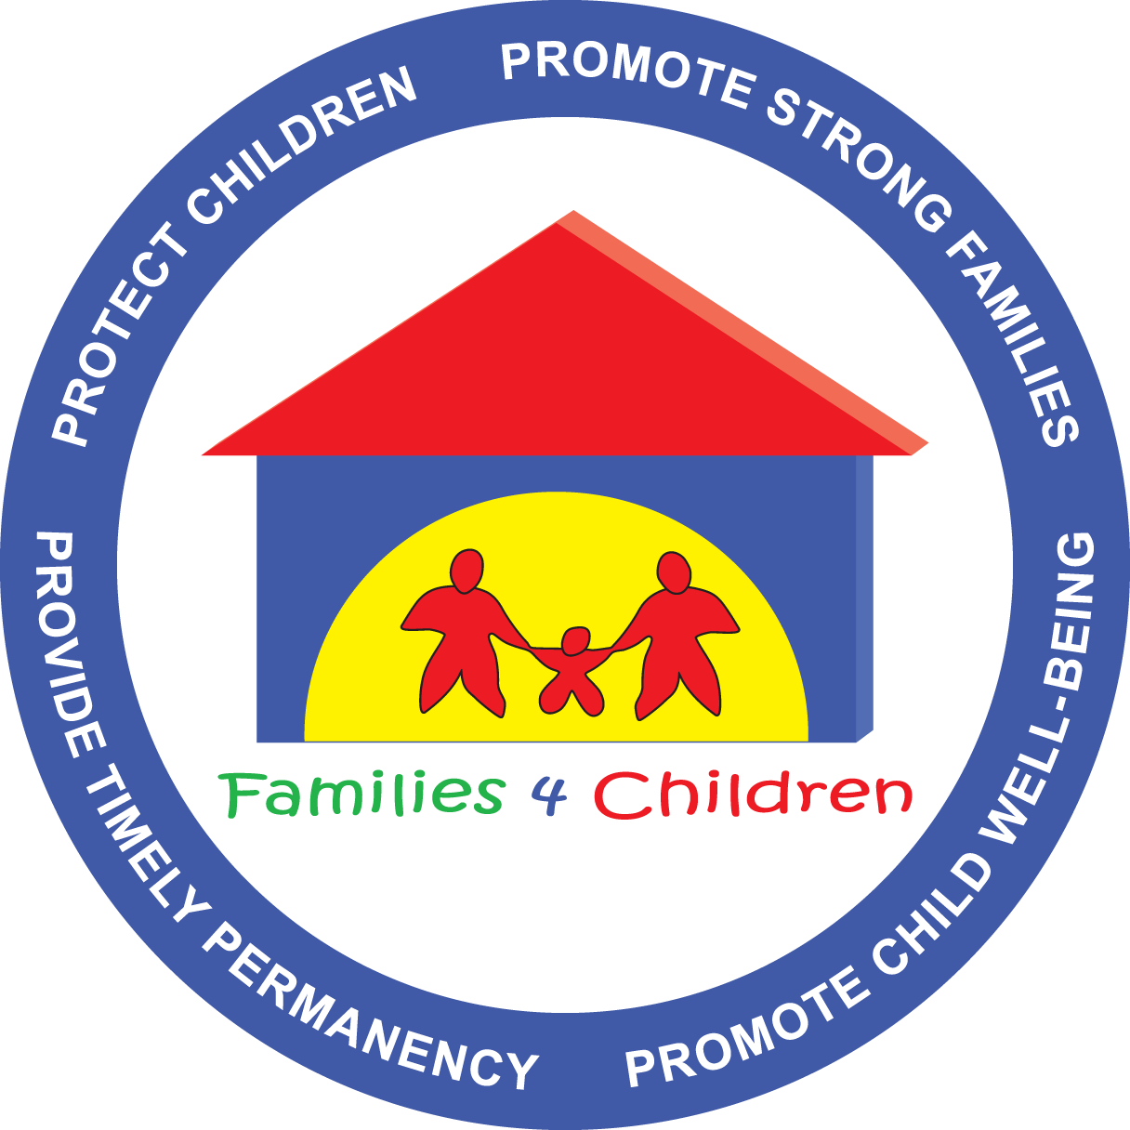

**Array of Local Service & Practice Alternatives**

The Congregate Care Workgroup identified an array of services and practices that have been proven successful to a reduction in the use of congregate care. This list groups solutions into four categories: Family Engagement, Community-based, System, and Service Alternatives. This list is not intended to be a complete and comprehensive list of all the possibilities. Knowing that each county has different resources and needs, it is meant to be a starting point for local discussion.

Using this list as a starting point, it is suggested that counties hold the following discussion at their local Children’s Roundtable:

1. What service or practice is needed?
2. Is this service or practice available in the community?
3. What are the barriers to having this service or practice in the community?
4. Who are the people (providers, mental health professionals, families, school leaders, managed care organizations, etc.) that need to be around the table to successfully implement this service or practice?

It is important to consider issues such as quality, availability, access, transportation, and capacity.

**Family Engagement Solutions**

* Family Finding
* Family engagement skills for professional staff
* Peer mentoring and supports
* Family meetings (including FGDM, Crisis/Rapid Response Family Meetings)
* Structure for building networks and lifetime supports

**Community-based Solutions**

* Family-based services
* Evening Reporting Center
* 24/7 supervision in the community
* Day centers
* One-stop shops for multiple services
* Intensive Behavioral Health Services (IBHS)
* Reimbursement incentives for resource families
* Enhanced training and supports to resource families
* Prevention service
* Diversion services
* School-based services

**System Solutions**

* Family Finding
* Service coordination to parents/entire family while the child in care is receiving services
* Community involvement and relationship building
  + Collaboration across systems (education, school, police, etc.) to improve relationships
* Stress management (for families/professionals)
* Blending resources
* Monitoring – Evidence-based practice
* Certified Trauma-Informed practice
  + (at all levels including screens, assessments, and services)
* County cultural change with leadership and staff that prioritizes children remaining in their county and community as the preferred option for all children
* Decisions based upon child and family needs assessment, not level-of-care recommendations
* Written decision making policy that emphasizes administrator approval

**Service Solutions**

* Emergency crisis response (24/7)
* Respite
* Professional foster parents
* Intensive in-home services
* Broad array of Mental Health services
* Mobile crisis response